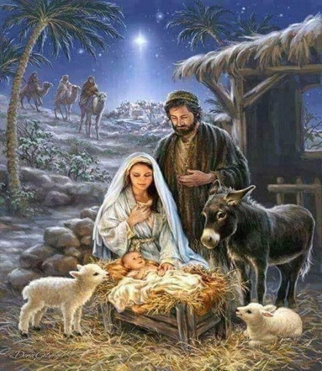

Divine Mercy Parish Christmas and New Year Masses

Saturday, December 23rd
4:00 p.m.—Saint Clement
4:00 p.m. – Saint John XXIII

Sunday, December 24th
9:00a.m.— Saint John XXIII
9:30a.m.— Saint Clement
11:00 a.m.—Saint Andrew

Christmas Eve Masses – Sunday, December 24th
7:00 p.m.—Saint Andrew
7:00 p.m.—Saint John XXIII
9:00 p.m.—Saint Clement
Midnight—Saint Andrew

Christmas Day Masses
9:30 a.m.— Saint Clement
10:00 a.m.—Saint John XXIII

Sunday, December 31
9:00 a.m.— Saint John XXIII
9:30 a.m.— Saint Clement
11:00 a.m.—Saint Andrew

New Year’s Eve – December 31
5:00 p.m. – Saint Andrew
New Year’s Day
10:00 a.m.—Saint Clement

